Open Ended Problem – 2
Aim: Develop a program that performs audio convolution and inverse filtering to reduce or
suppress background music in a given song using different impulse responses.
Code:
# AIM: Audio Convolution and Inverse Filtering for Background Music Suppression
import numpy as np
import matplotlib.pyplot as plt
import scipy.signal as signal
import scipy.io.wavfile as wavfile
import librosa

def create_impulse_responses(sr):
delay_samples = int(0.05 * sr)
ir_echo = np.zeros(delay_samples + 1)
ir_echo[0] = 1.0
ir_echo[-1] = 0.5

t_ir = np.linspace(0, 0.2, int(0.2 * sr))
ir_reverb = np.exp(-15 * t_ir) * np.random.randn(len(t_ir))
ir_reverb[0] = 1.0

ir_lowpass = signal.firwin(101, cutoff=2500, fs=sr)

return {
"1_Echo_Delay": ir_echo,
"2_Room_Reverberation": ir_reverb,
"3_LowPass_Dampening": ir_lowpass
}

def regularized_inverse_filter(h, epsilon=1e-2, n_fft=262144):
H = np.fft.rfft(h, n=n_fft)
G = np.conj(H) / (np.abs(H)**2 + epsilon)
g = np.fft.irfft(G, n=n_fft)
return np.real(g)

def run_audio_experiment(audio_path):
print(f"Loading MP3 audio file: {audio_path}...")

audio_data, sr = librosa.load(audio_path, sr=None, mono=True, duration=10.0)

audio_data = audio_data / np.max(np.abs(audio_data))

impulse_responses = create_impulse_responses(sr)

plt.figure(figsize=(12, 10))

plt.subplot(4, 1, 1)
plt.plot(audio_data, color='k', alpha=0.7)
plt.title("Original MP3 Audio Track")
plt.ylabel("Amplitude")
plt.grid(True)

plot_idx = 2

for name, ir in impulse_responses.items():
print(f"Processing IR: {name}...")

convolved_audio = signal.fftconvolve(audio_data, ir, mode='same')

inv_filter = regularized_inverse_filter(ir, epsilon=1e-2)

filtered_audio = signal.fftconvolve(convolved_audio, inv_filter, mode='same')
filtered_audio = filtered_audio[:len(audio_data)]

output_filename = f"output_{name}.wav"
wavfile.write(output_filename, sr, (filtered_audio * 32767).astype(np.int16))
print(f" -> Processed track saved to: {output_filename}")

plt.subplot(4, 1, plot_idx)
plt.plot(filtered_audio, alpha=0.8)
plt.title(f"Inverse Filtered Output ({name})")
plt.ylabel("Amplitude")
plt.grid(True)
plot_idx += 1

plt.xlabel("Sample Index")
plt.tight_layout()
plt.show()

run_audio_experiment('song.mp3')

Output:
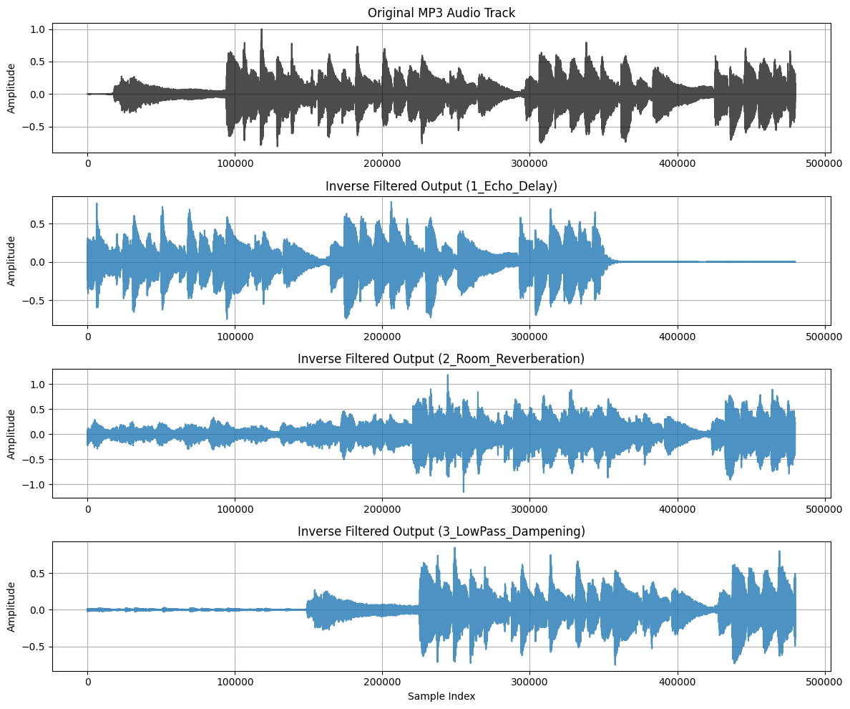

Conclusion :
In this experiment, audio convolution and regularized inverse filtering were applied to an audio track (.mp3) across multiple synthetic impulse responses (Echo/Delay, Room Reverberation, and Low-Pass Dampening).
The results demonstrate that inverse filtering successfully restores or equalizes acoustic channel distortions - such as suppressing discrete echoes or reducing room reverberation tails - when the system's impulse response is known. However, the experiment highlights a fundamental limitation of linear filtering: inverse filtering acts as a global system equalizer and cannot perform blind source separation (such as isolating vocals/lyrics from digital background music) because both components share overlapping frequency bands within the same composite waveform.

